Online Library 1

<https://openlibrary.org/>

HOME PAGE

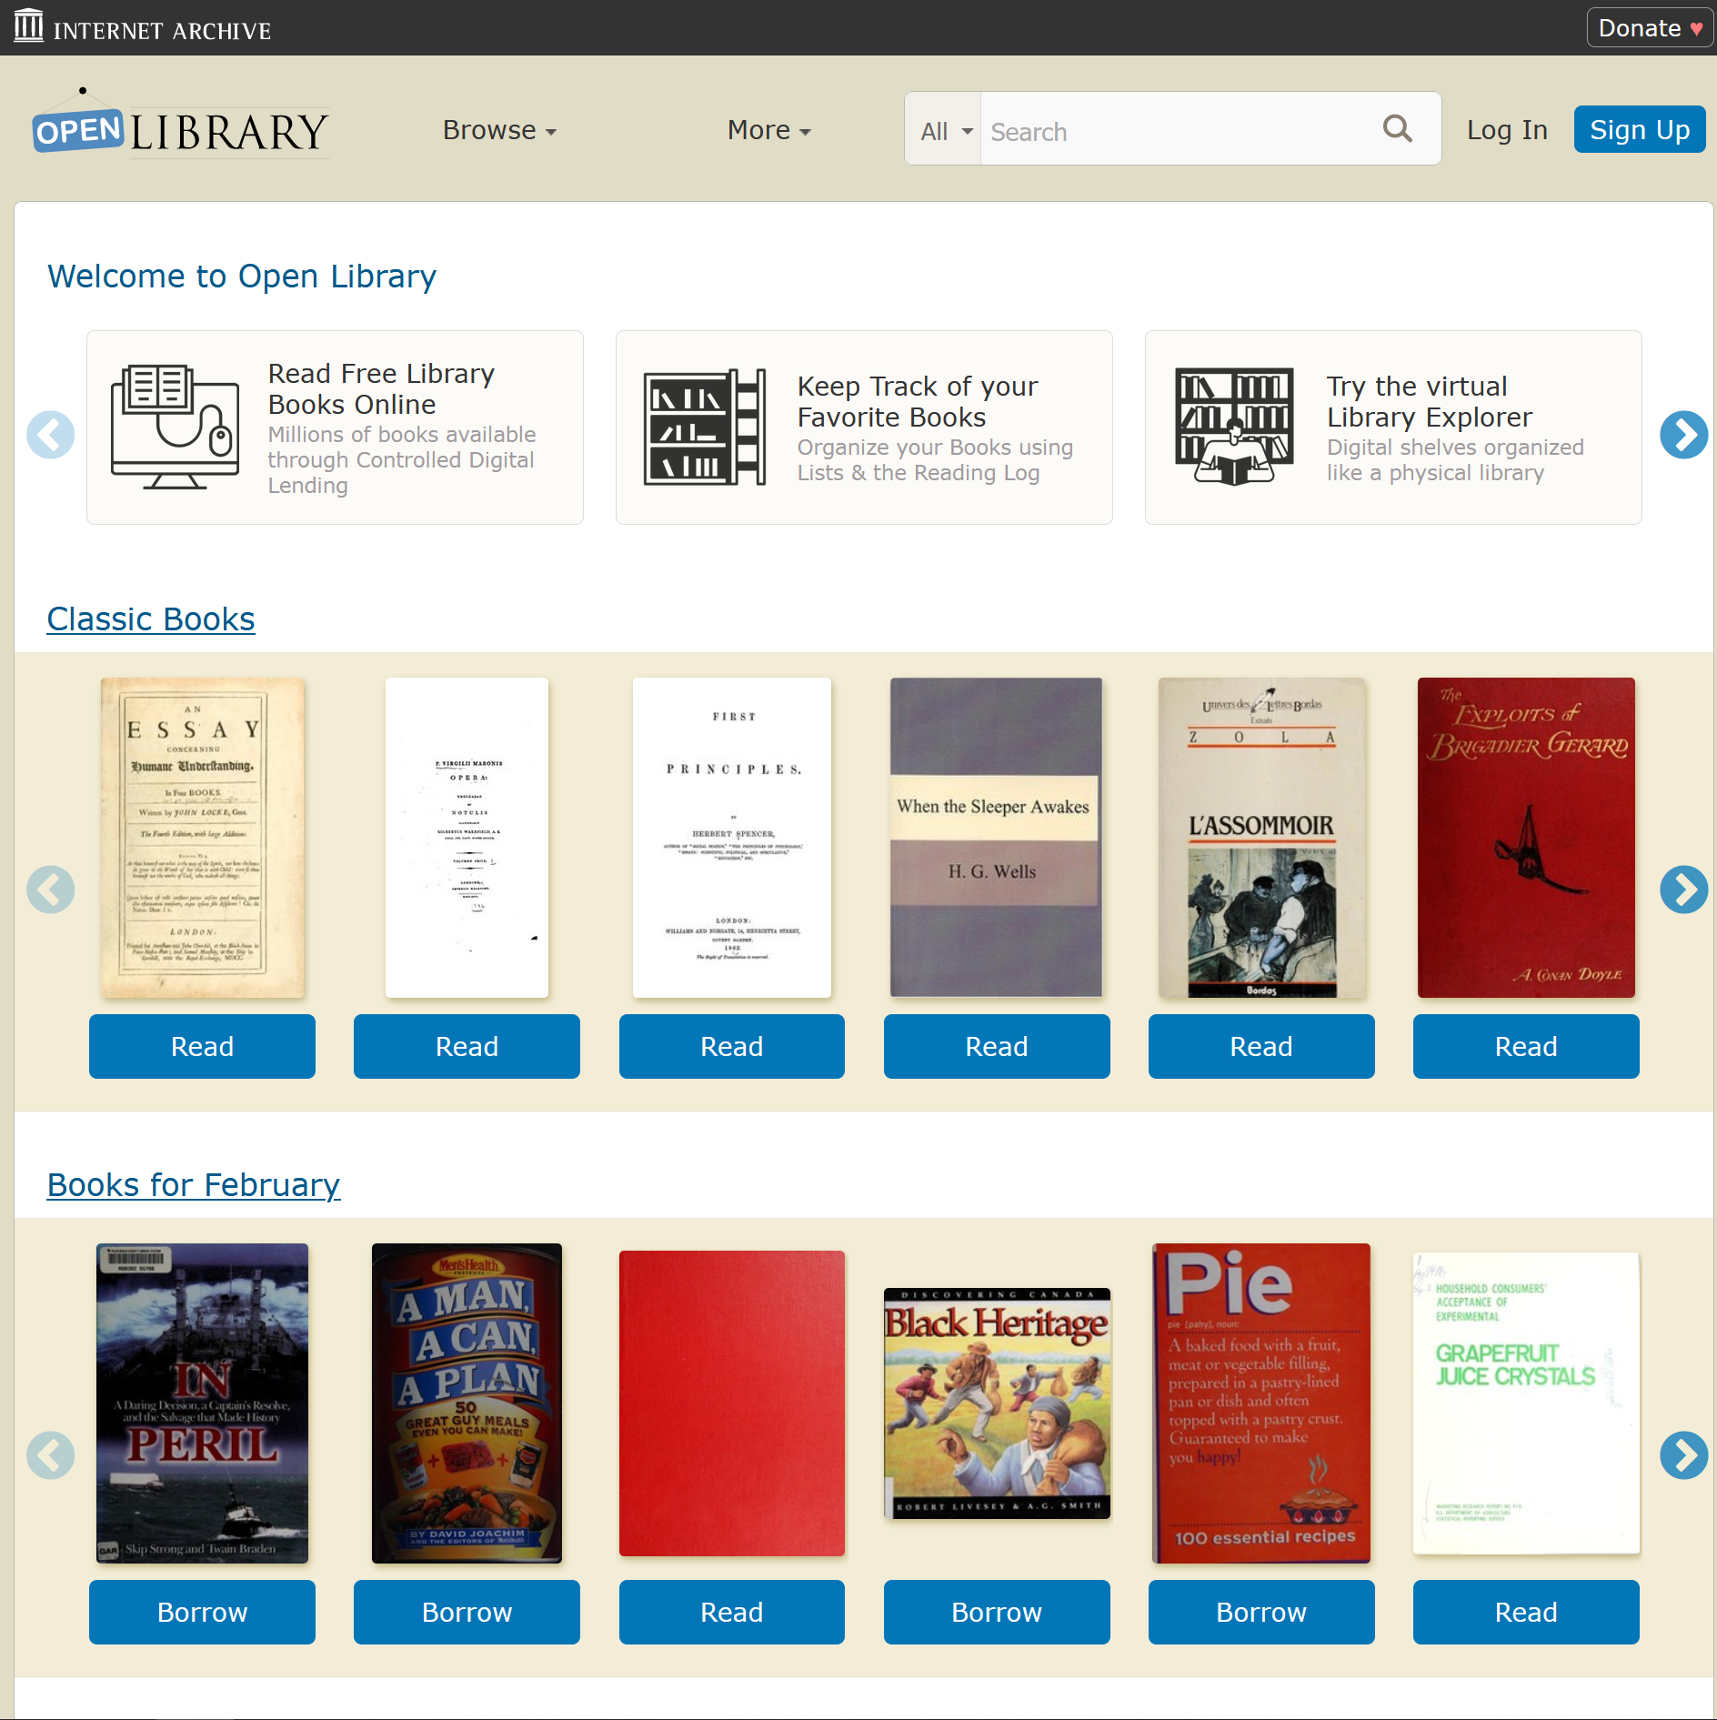

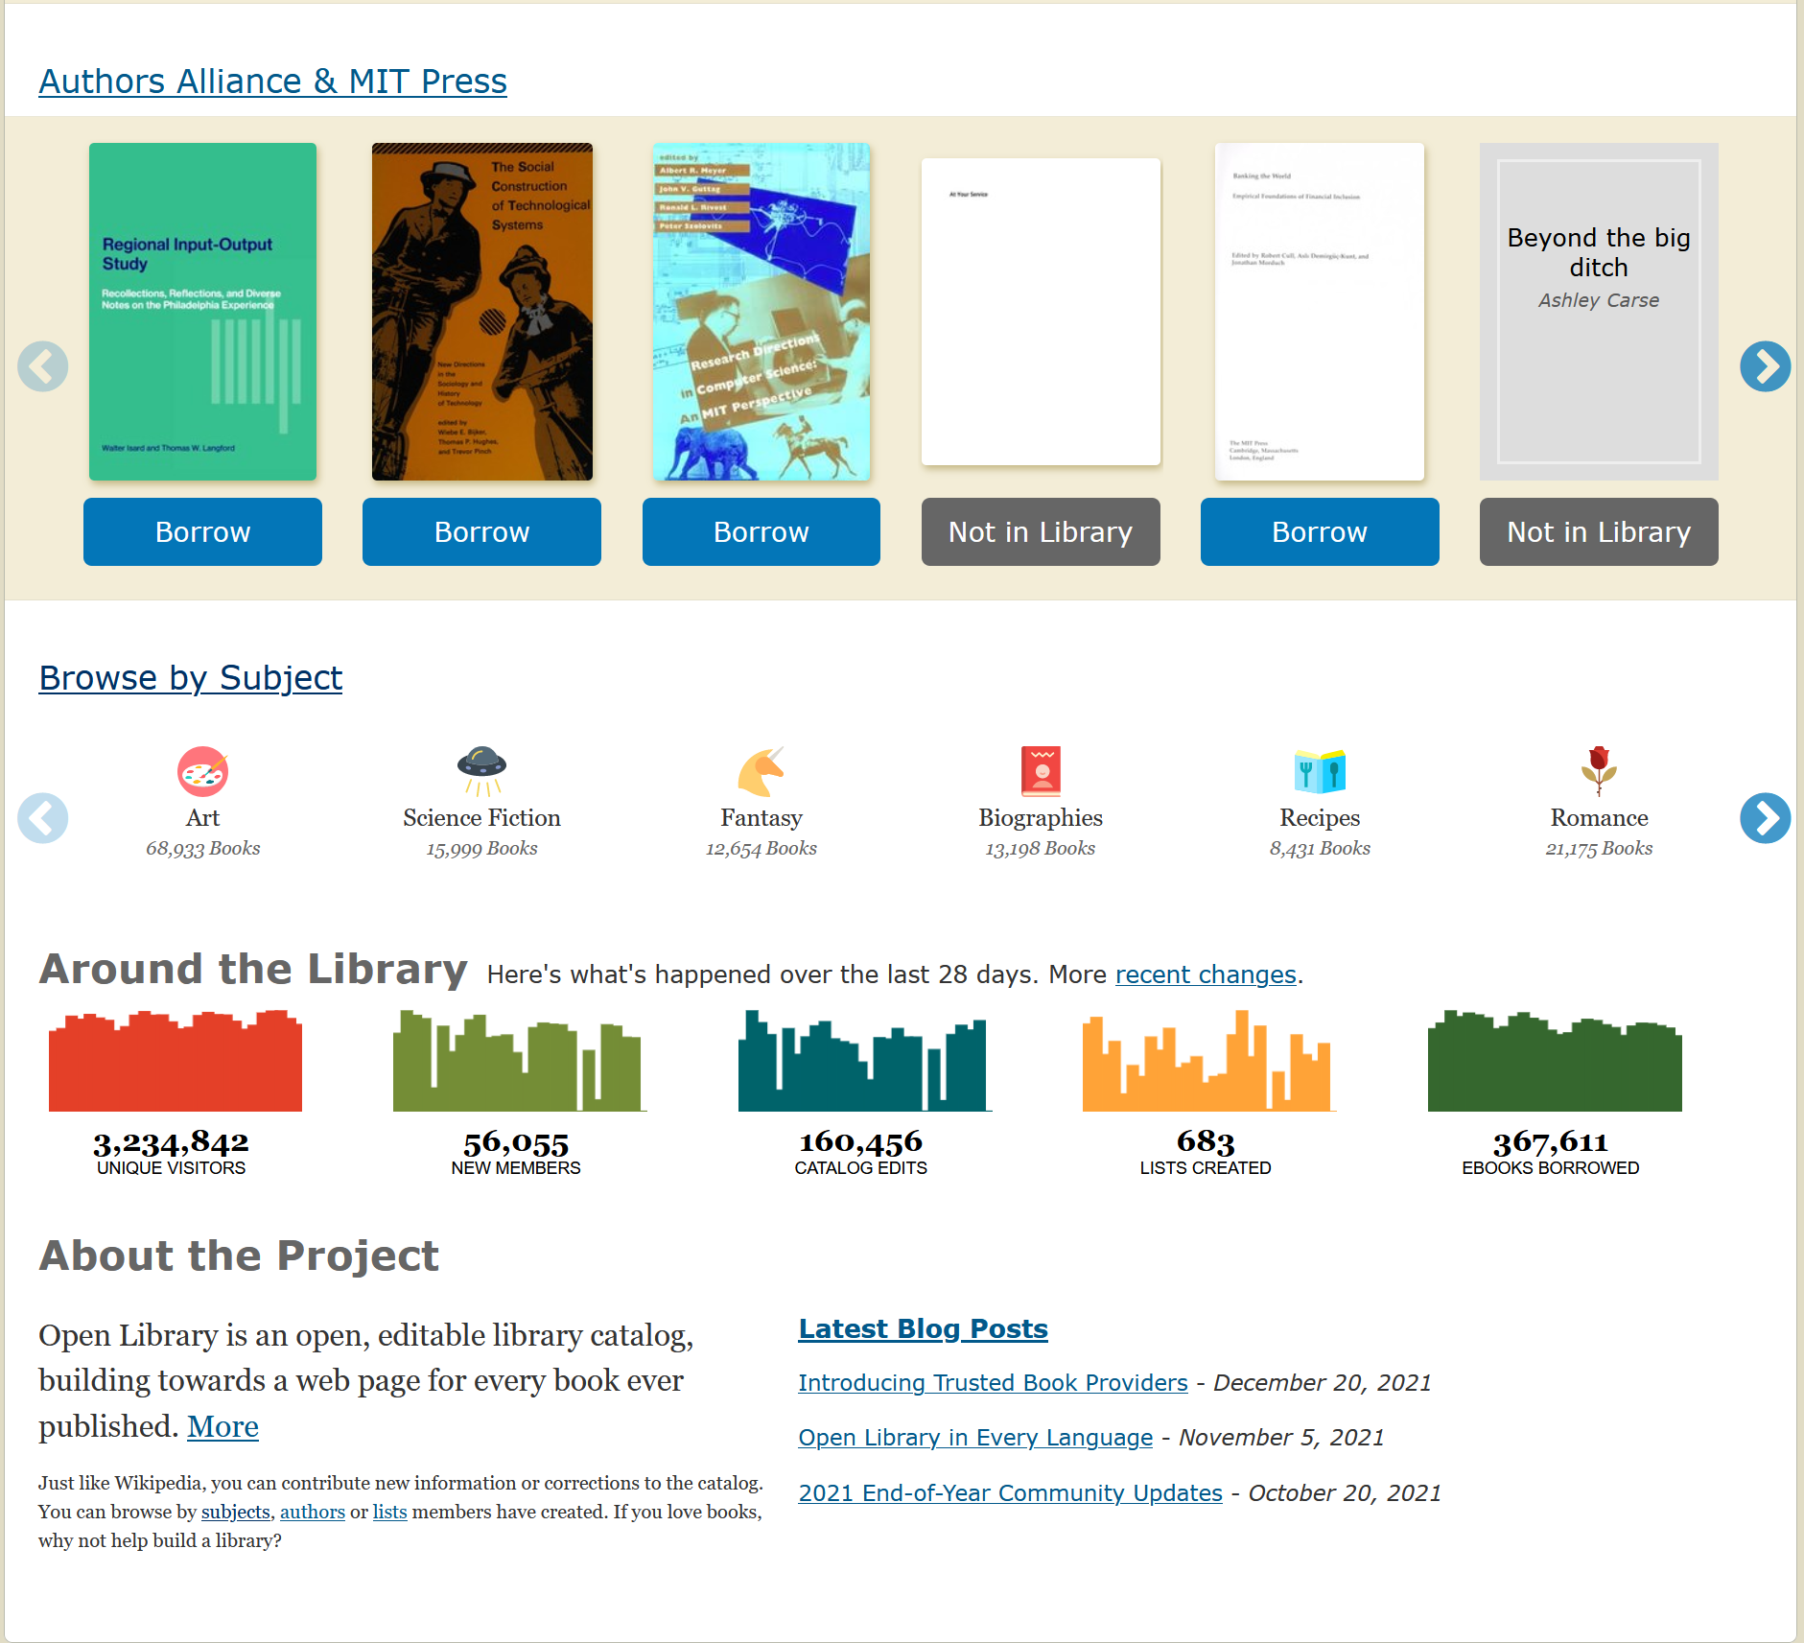

BOOK PREVIEW

<https://archive.org/details/essayconcerningh00loc/page/266/mode/2up?ref=ol&view=theater>

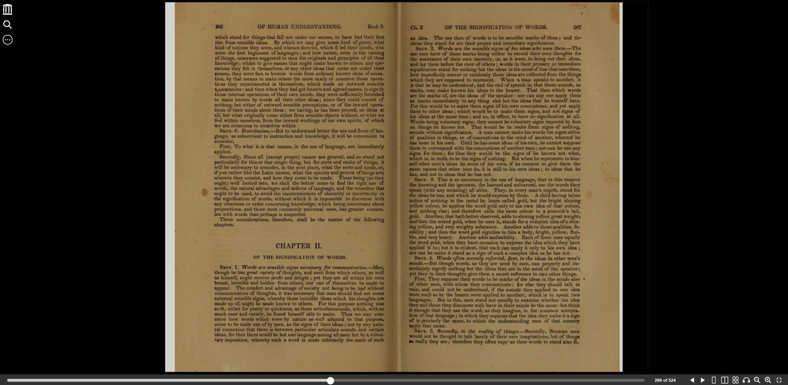

LOG IN / SIGN UP

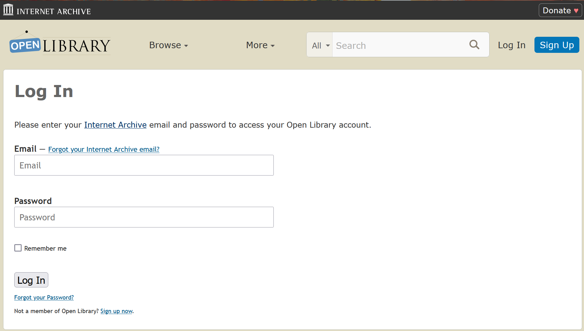

BOOK BORROWING / BOOK READING

<https://archive.org/details/rollergirl0000jami/page/n1/mode/2up?view=theater>

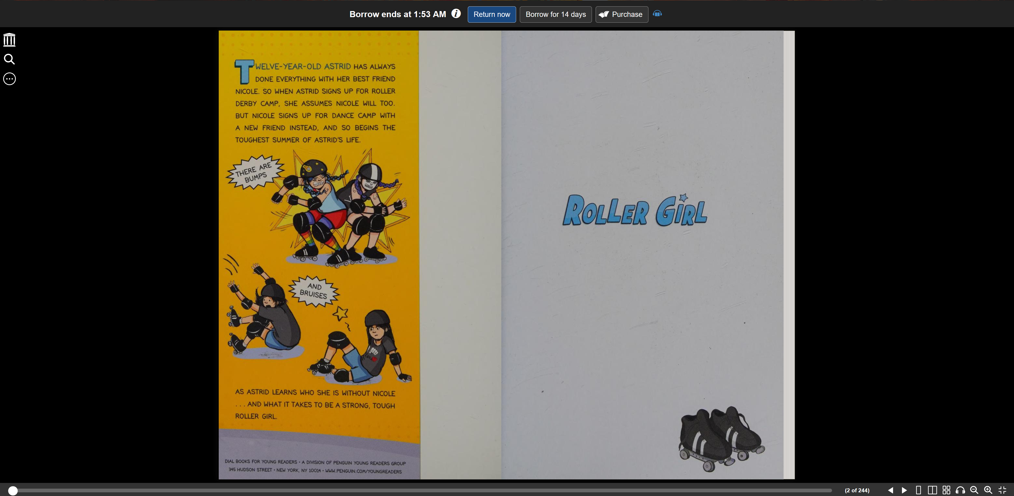

Online Library 2

<https://onlinelibrary.wiley.com/>

HOME PAGE

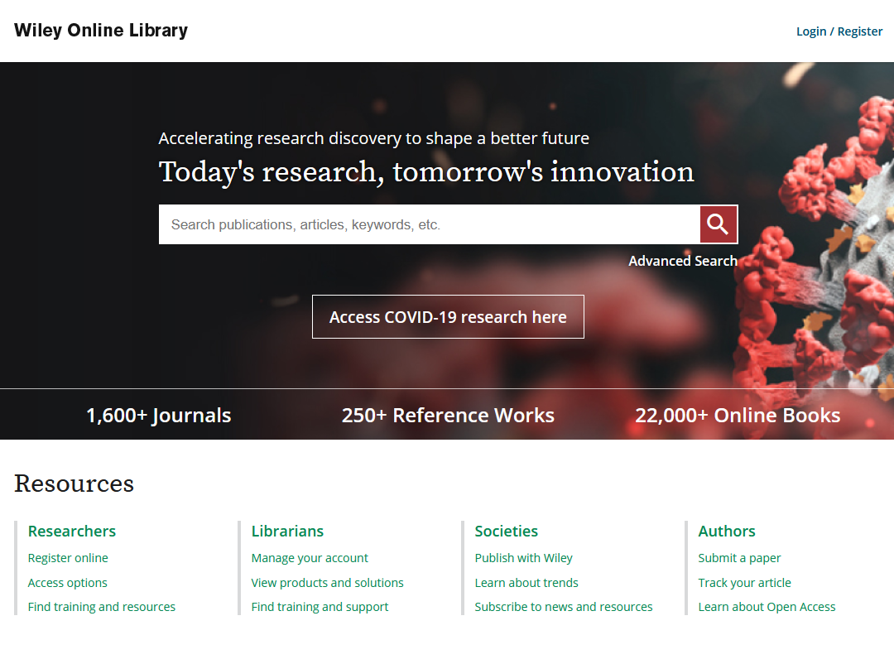

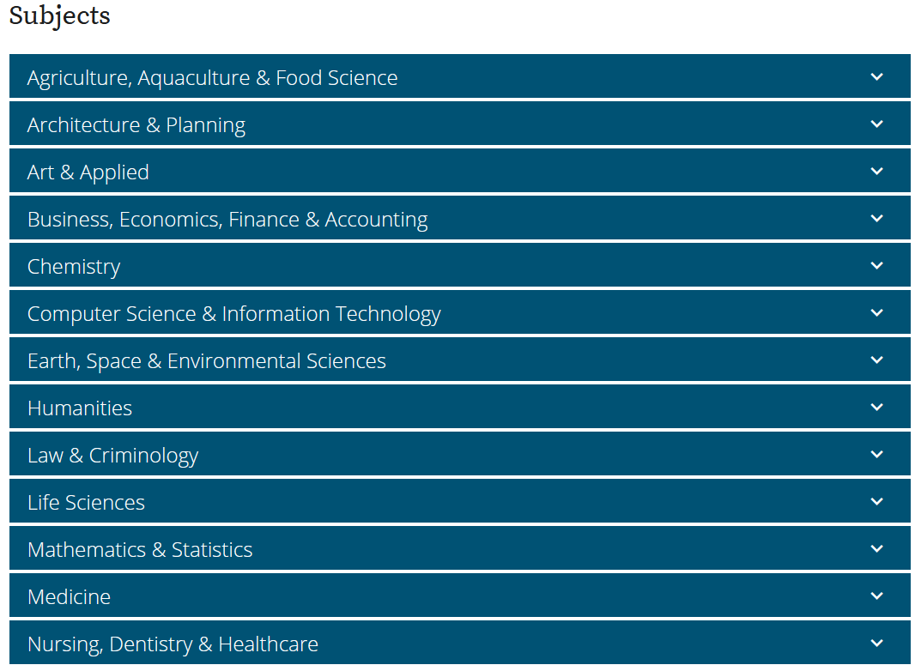

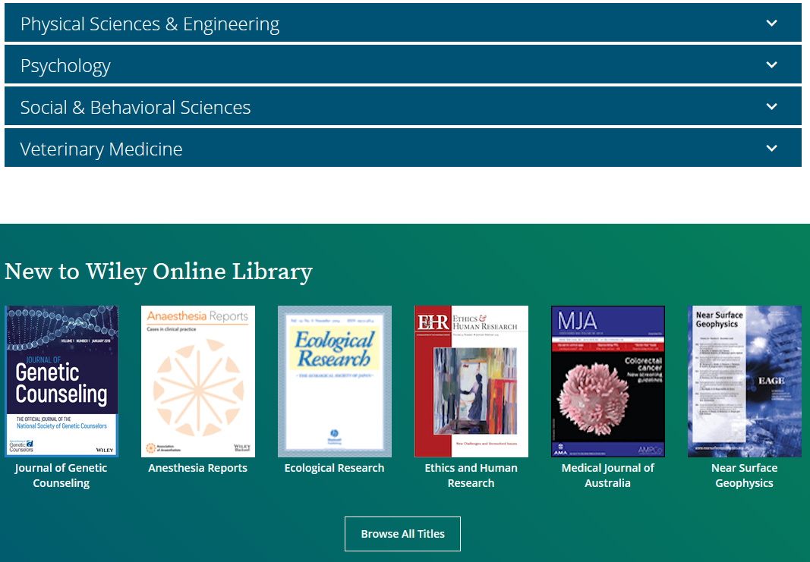

SUBJECTS / FILTERS



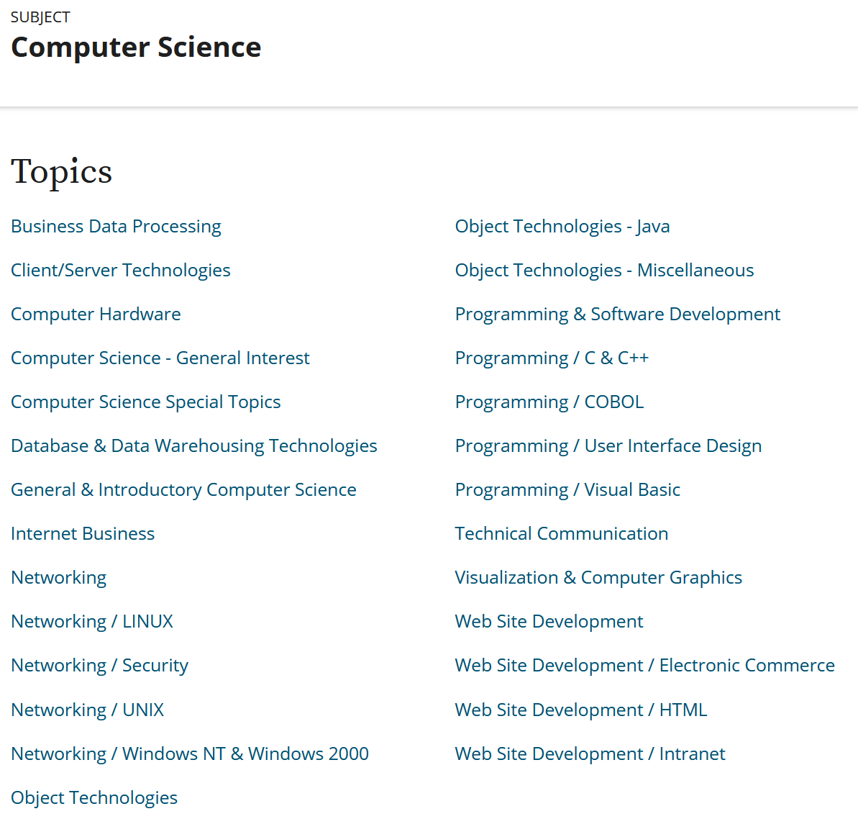

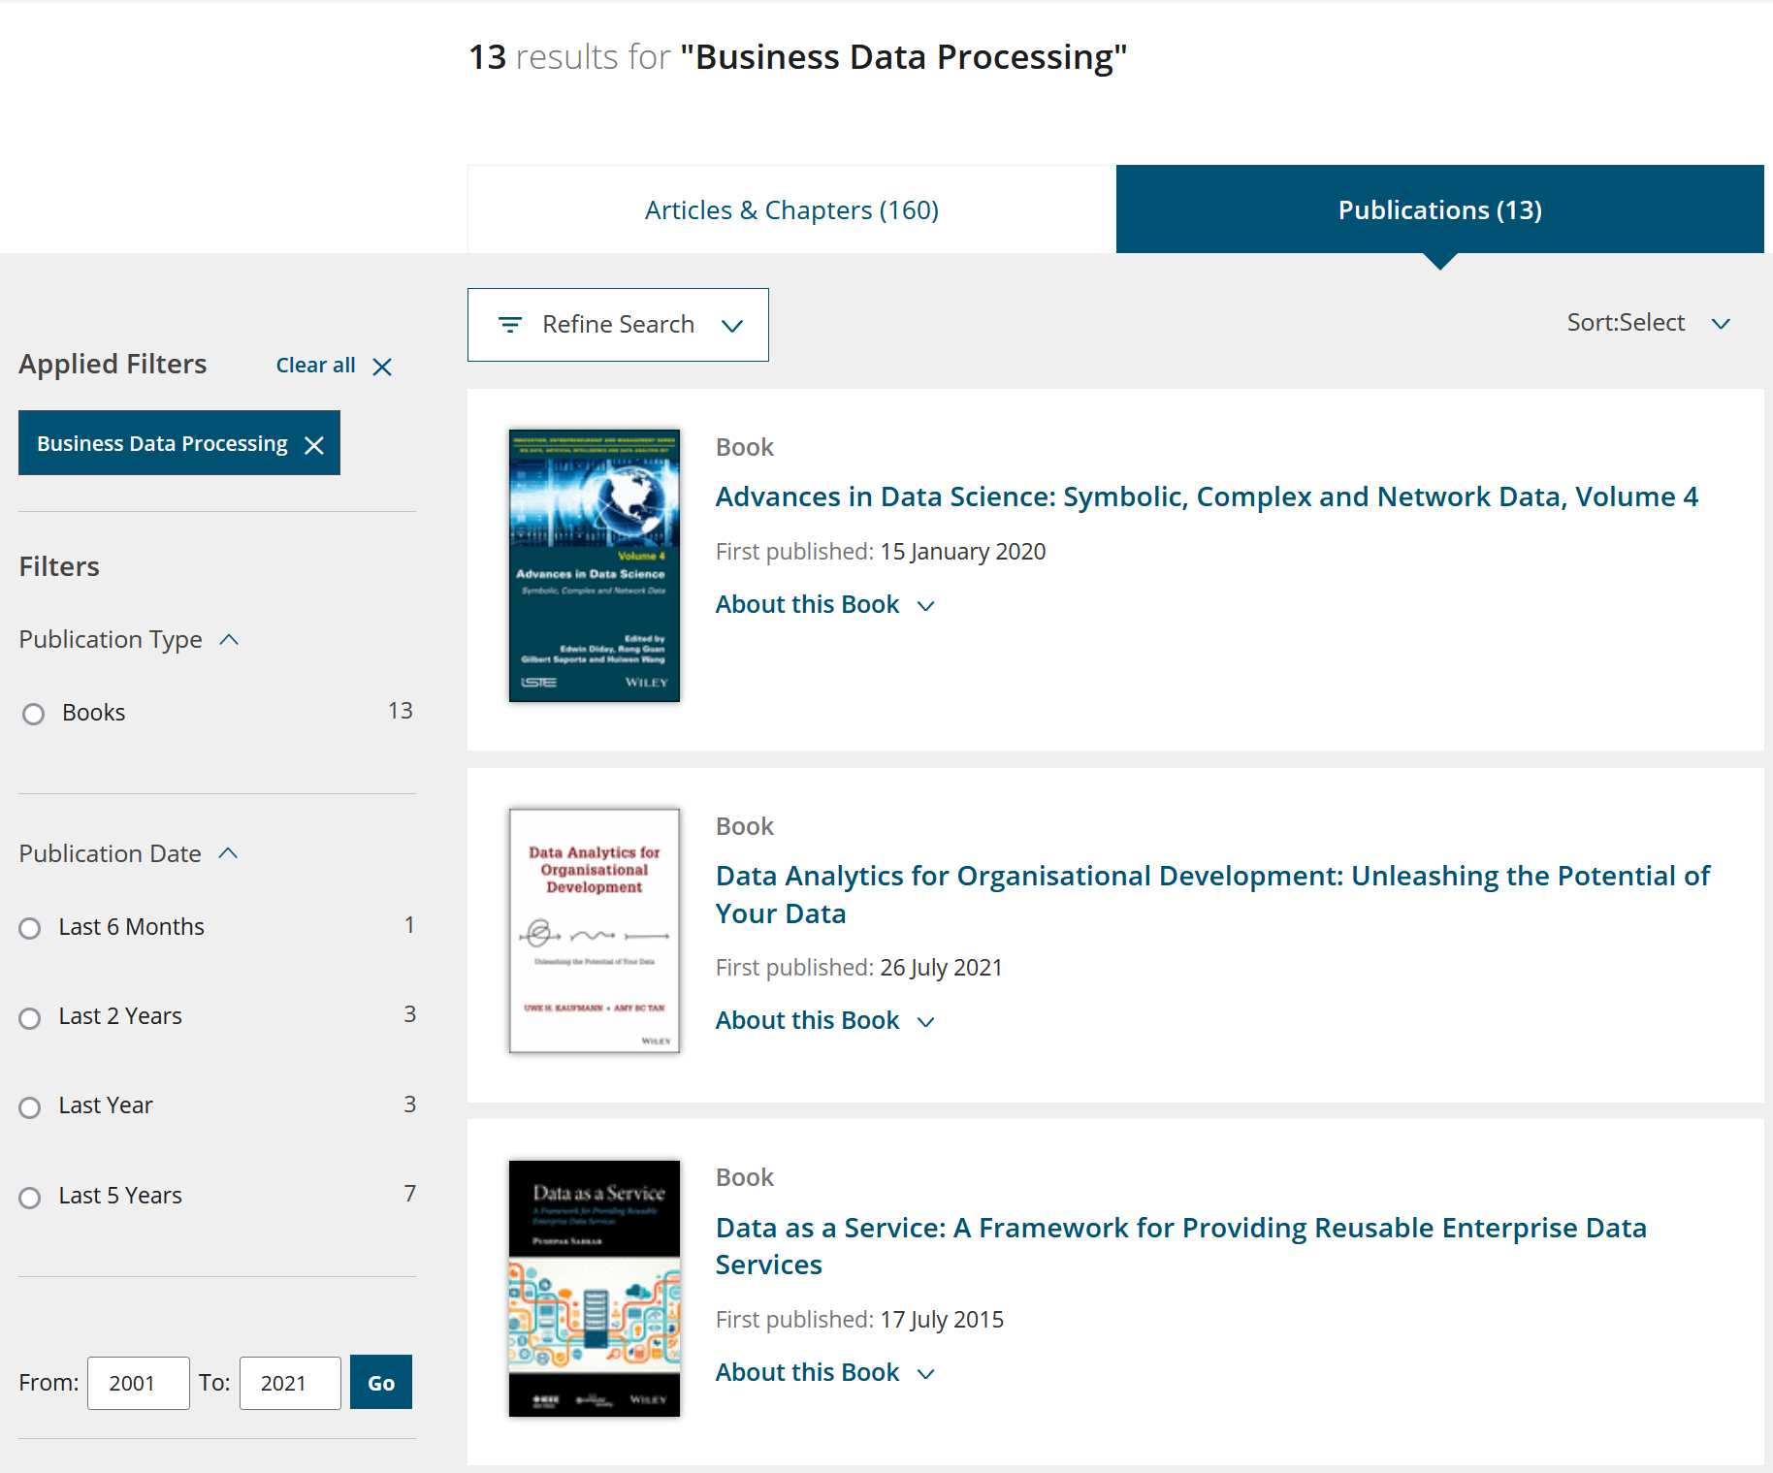

BOOK VIEWING

<https://onlinelibrary.wiley.com/doi/book/10.1002/9781119695110>

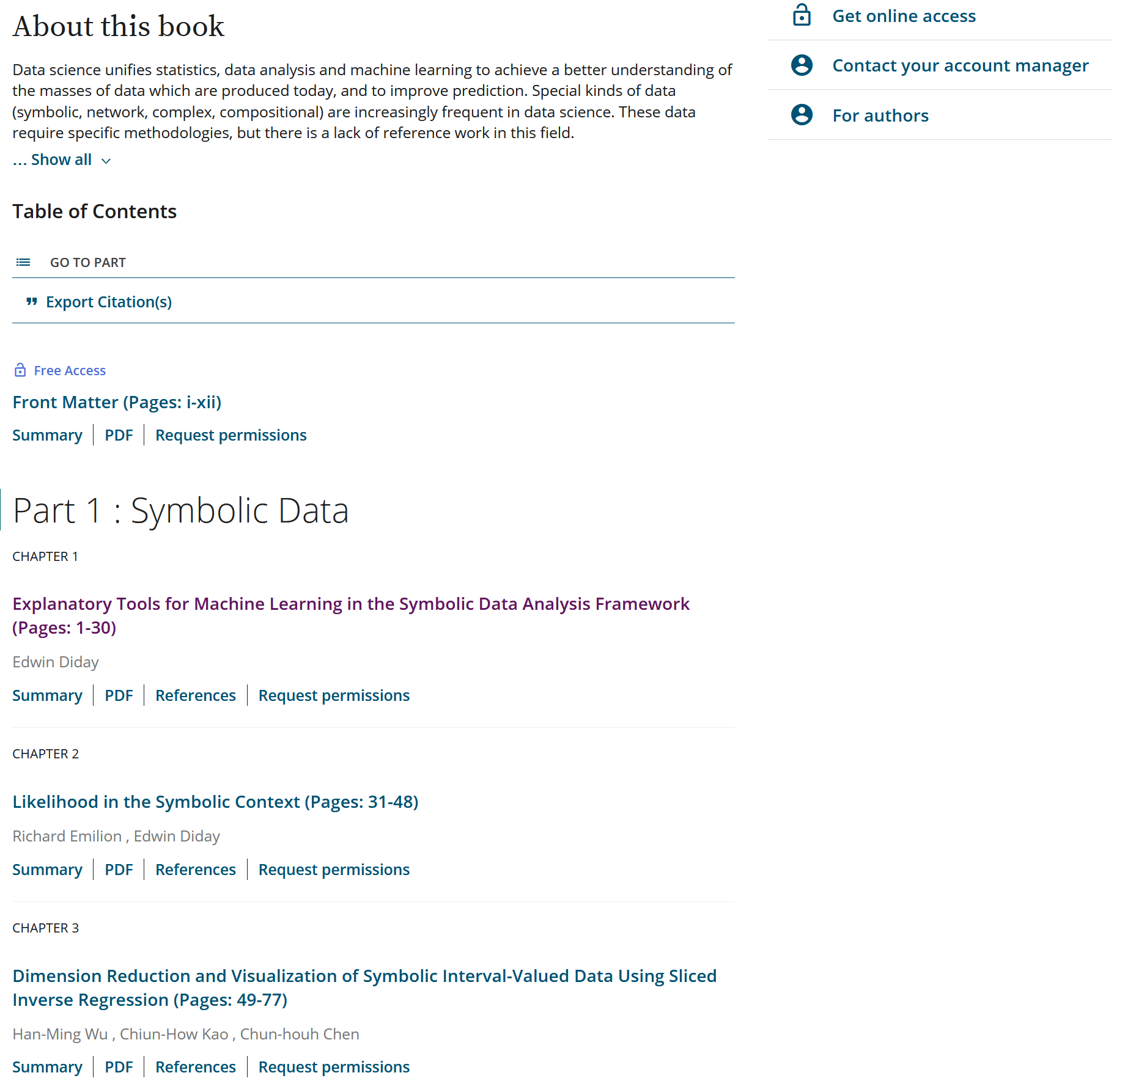

Online Library 3

<https://www.publicbookshelf.com/index.html>

HOME PAGE

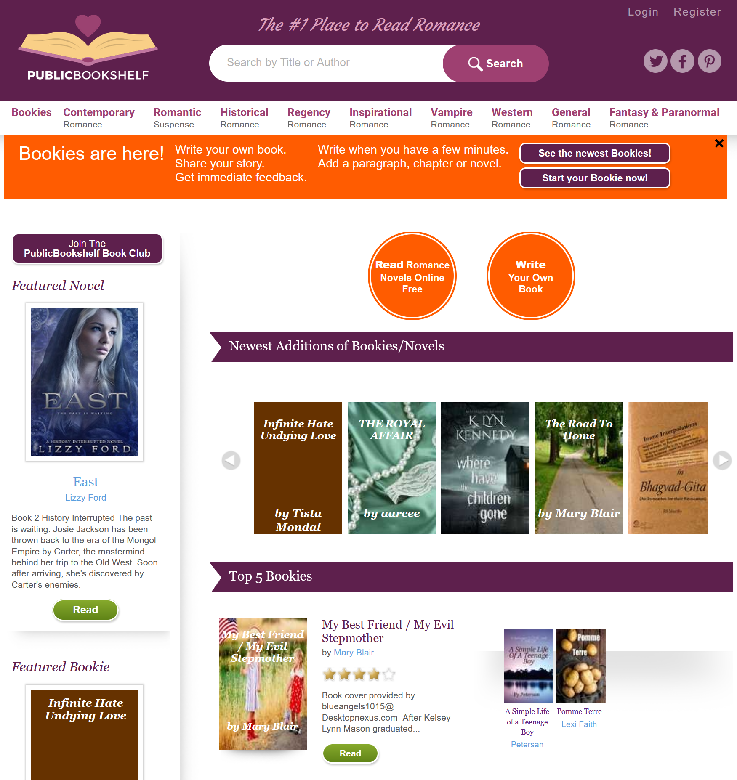

BOOK PREVIEW / COMMENTS

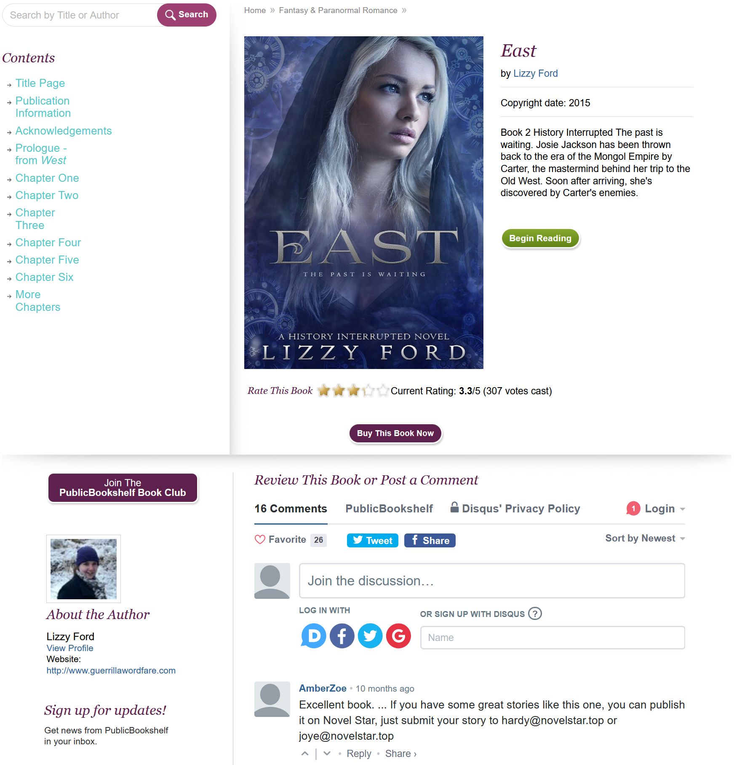

BOOK READING

<https://www.publicbookshelf.com/fantasy-paranormal/east/title-page>

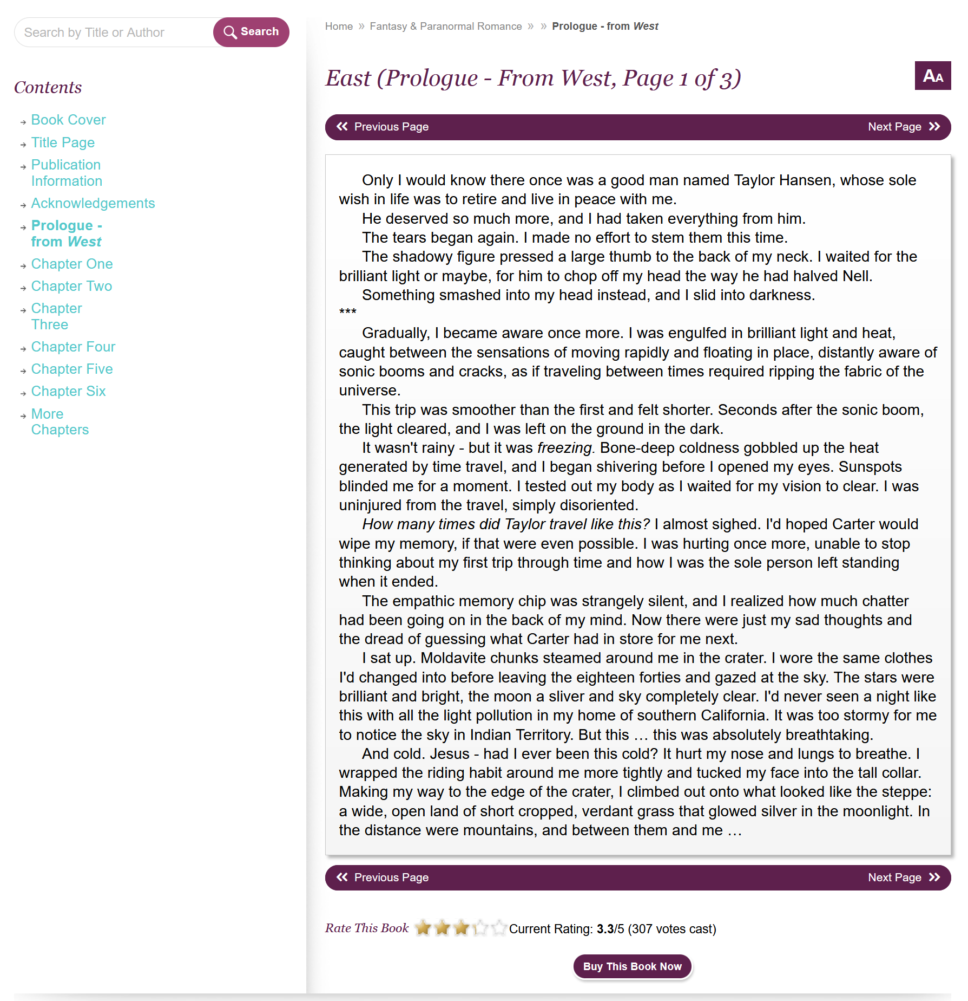

ONLINE PAYMENT

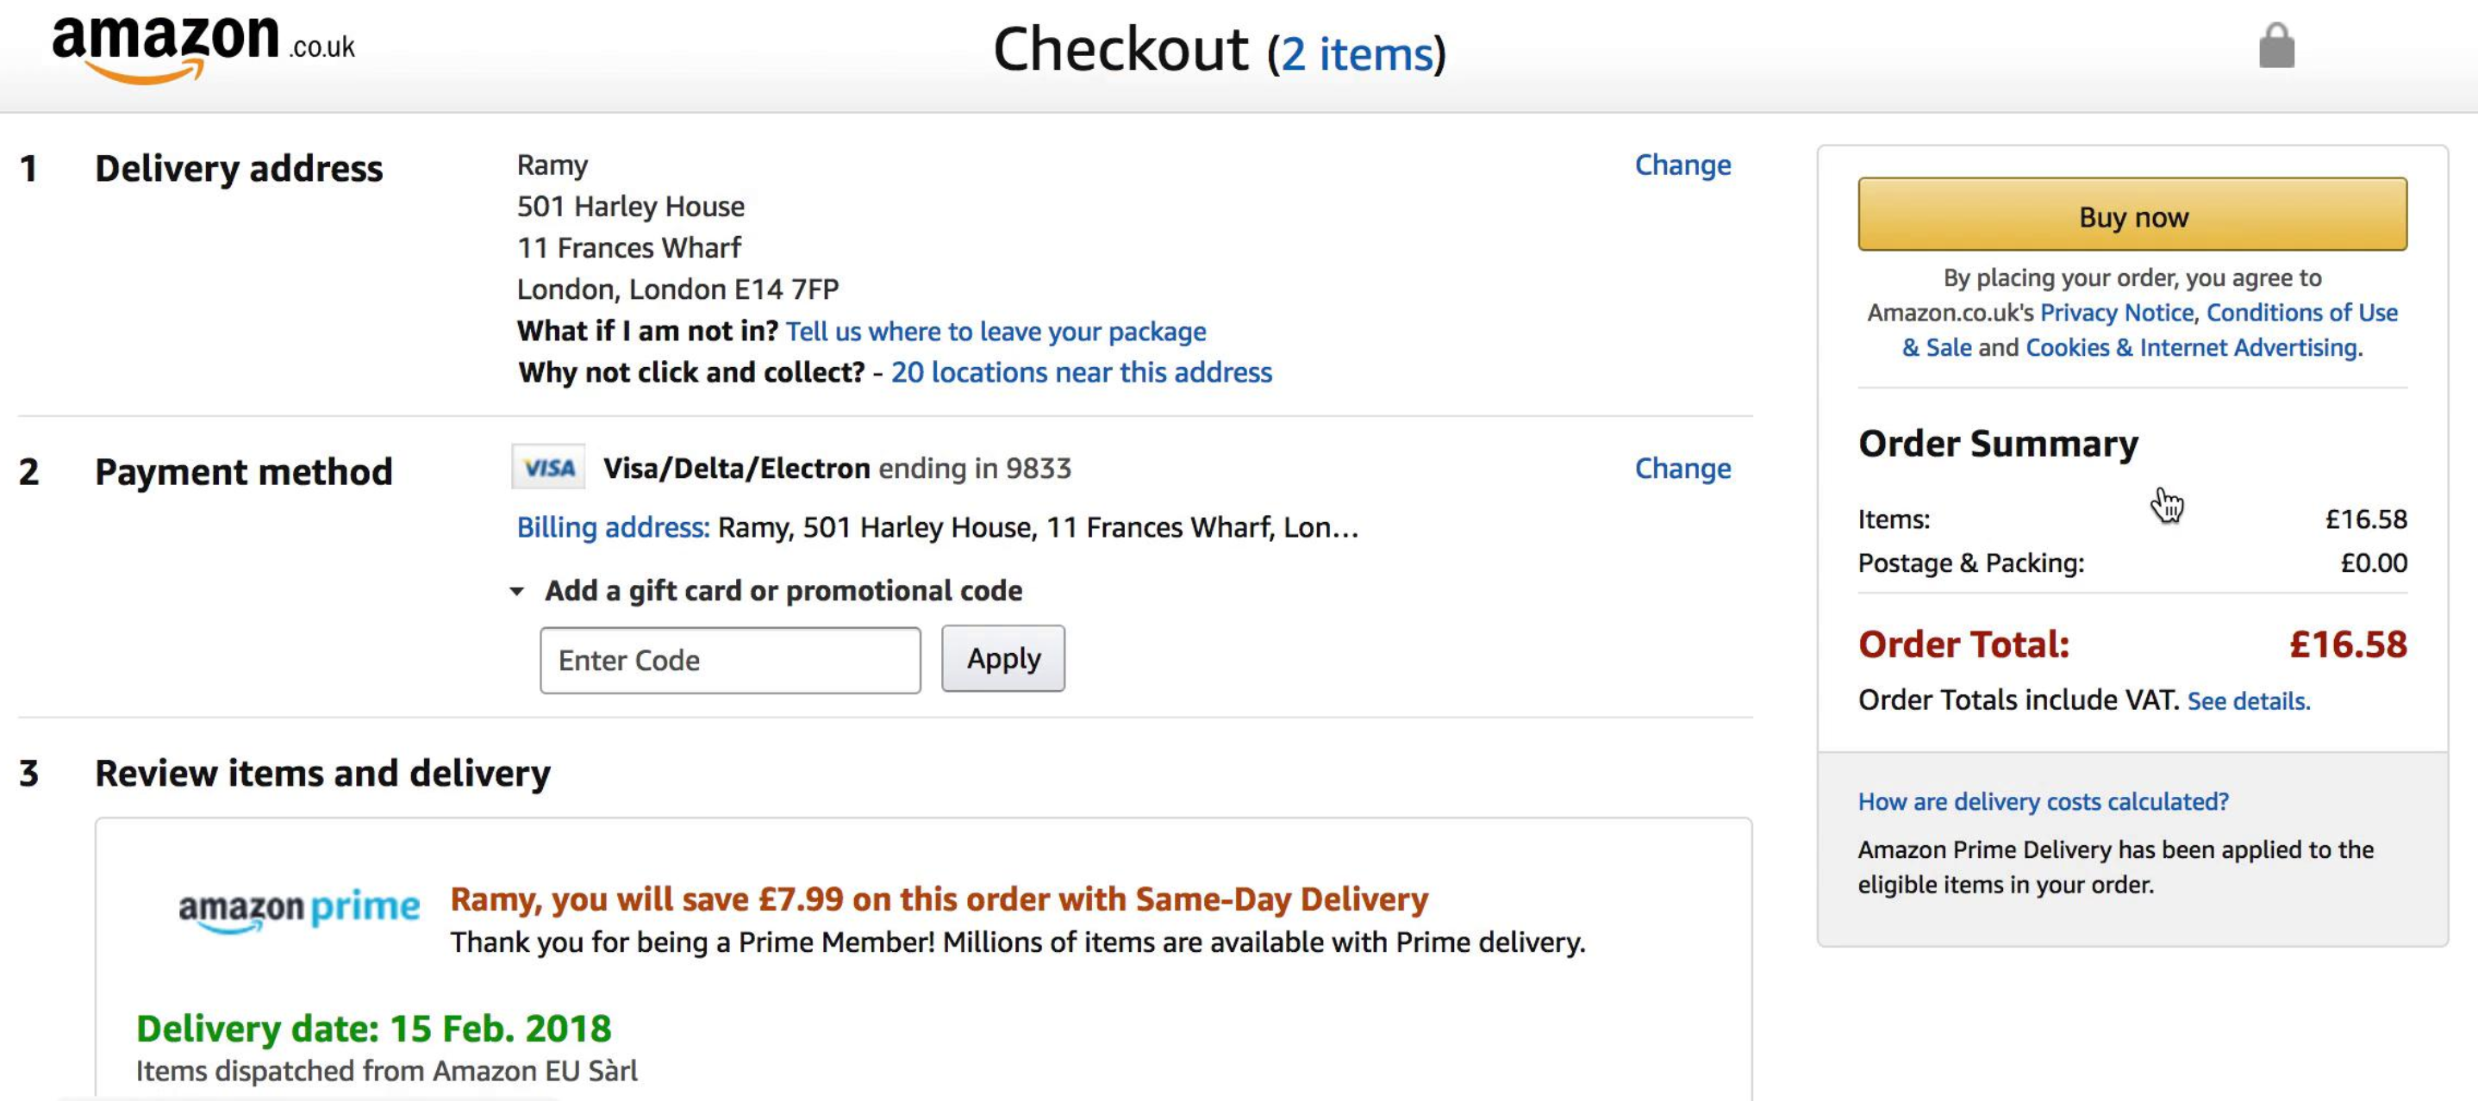

MOCK-UPS

HOME PAGE

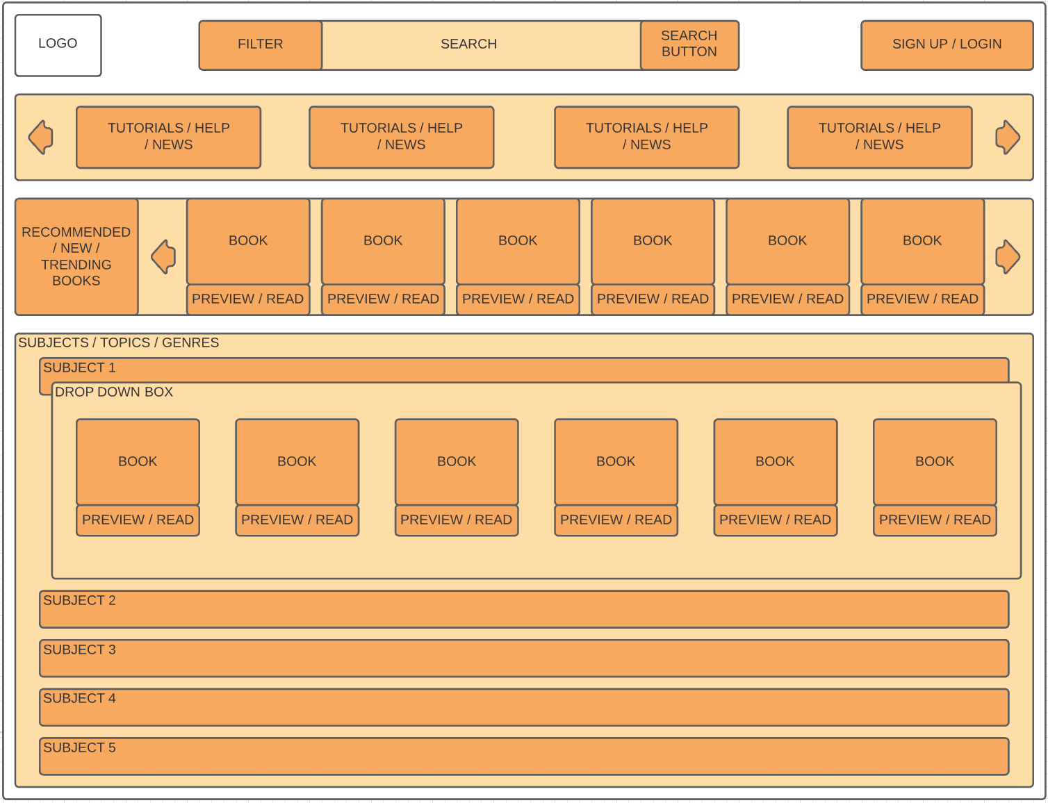

Button colour : Hex #f7a960 (Dark Orange)

Background banner colour : Hex #ffdda6 (Light Orange)

Text boxes for users: Hex #ffffff (White)

SIGN UP / LOGIN

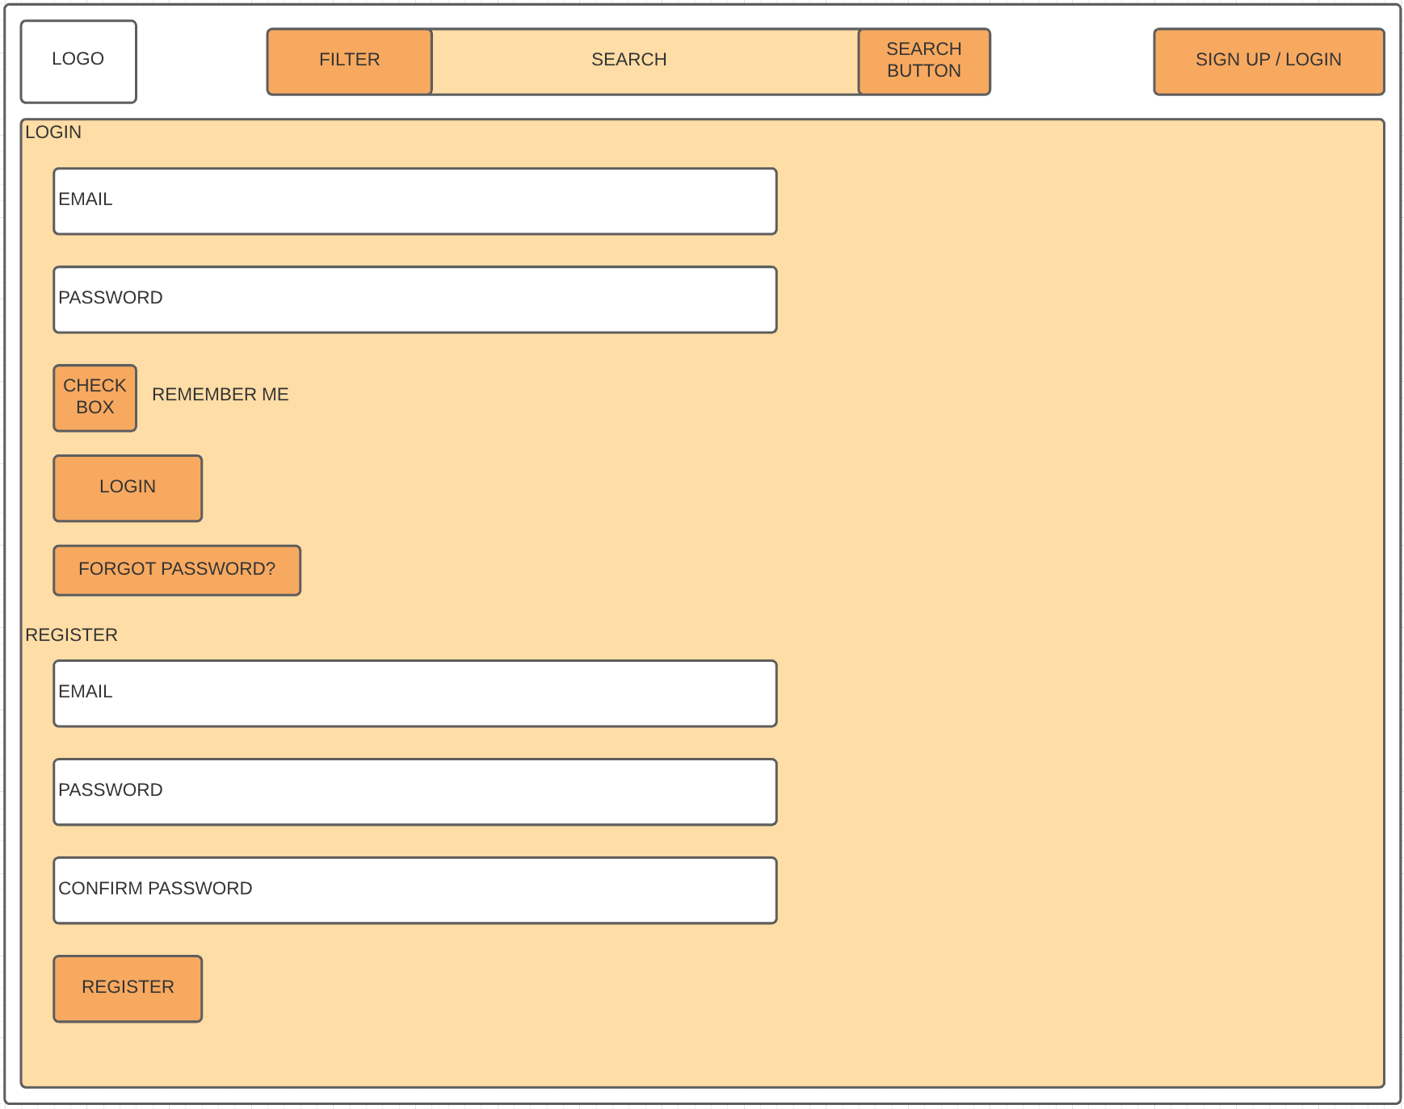

Button colour : Hex #f7a960 (Dark Orange)

Background banner colour : Hex #ffdda6 (Light Orange)

Text boxes for users: Hex #ffffff (White)

RESULTS FROM SEARCH PAGE

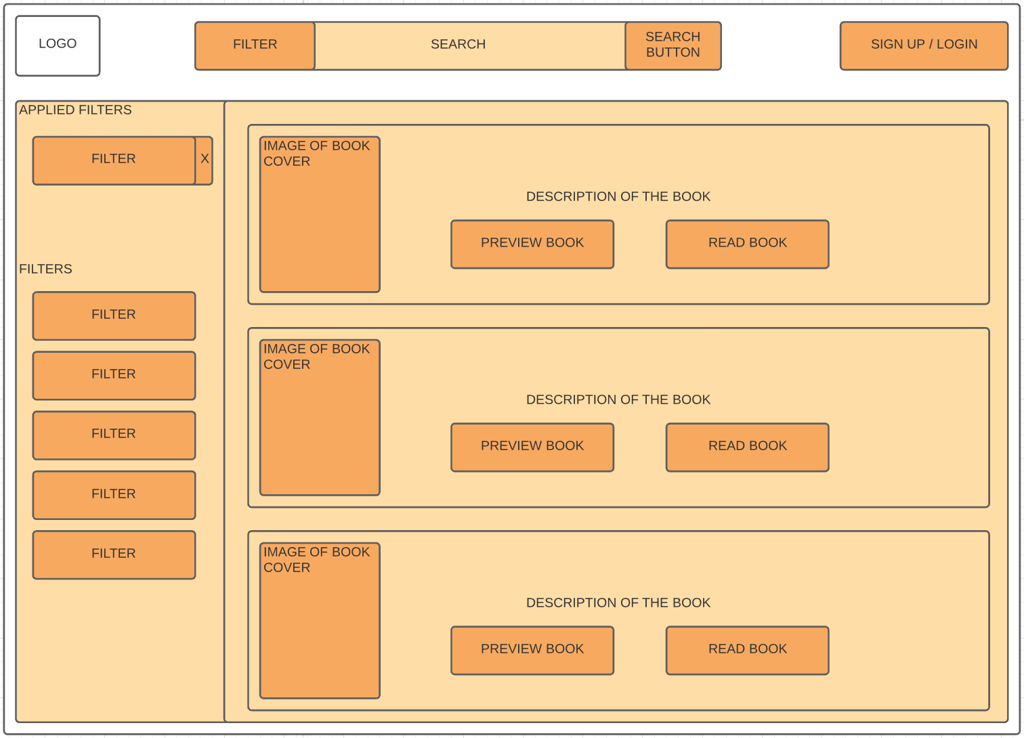

Button colour : Hex #f7a960 (Dark Orange)

Background banner colour : Hex #ffdda6 (Light Orange)

Text boxes for users: Hex #ffffff (White)

BOOK PREVIEW PAGE

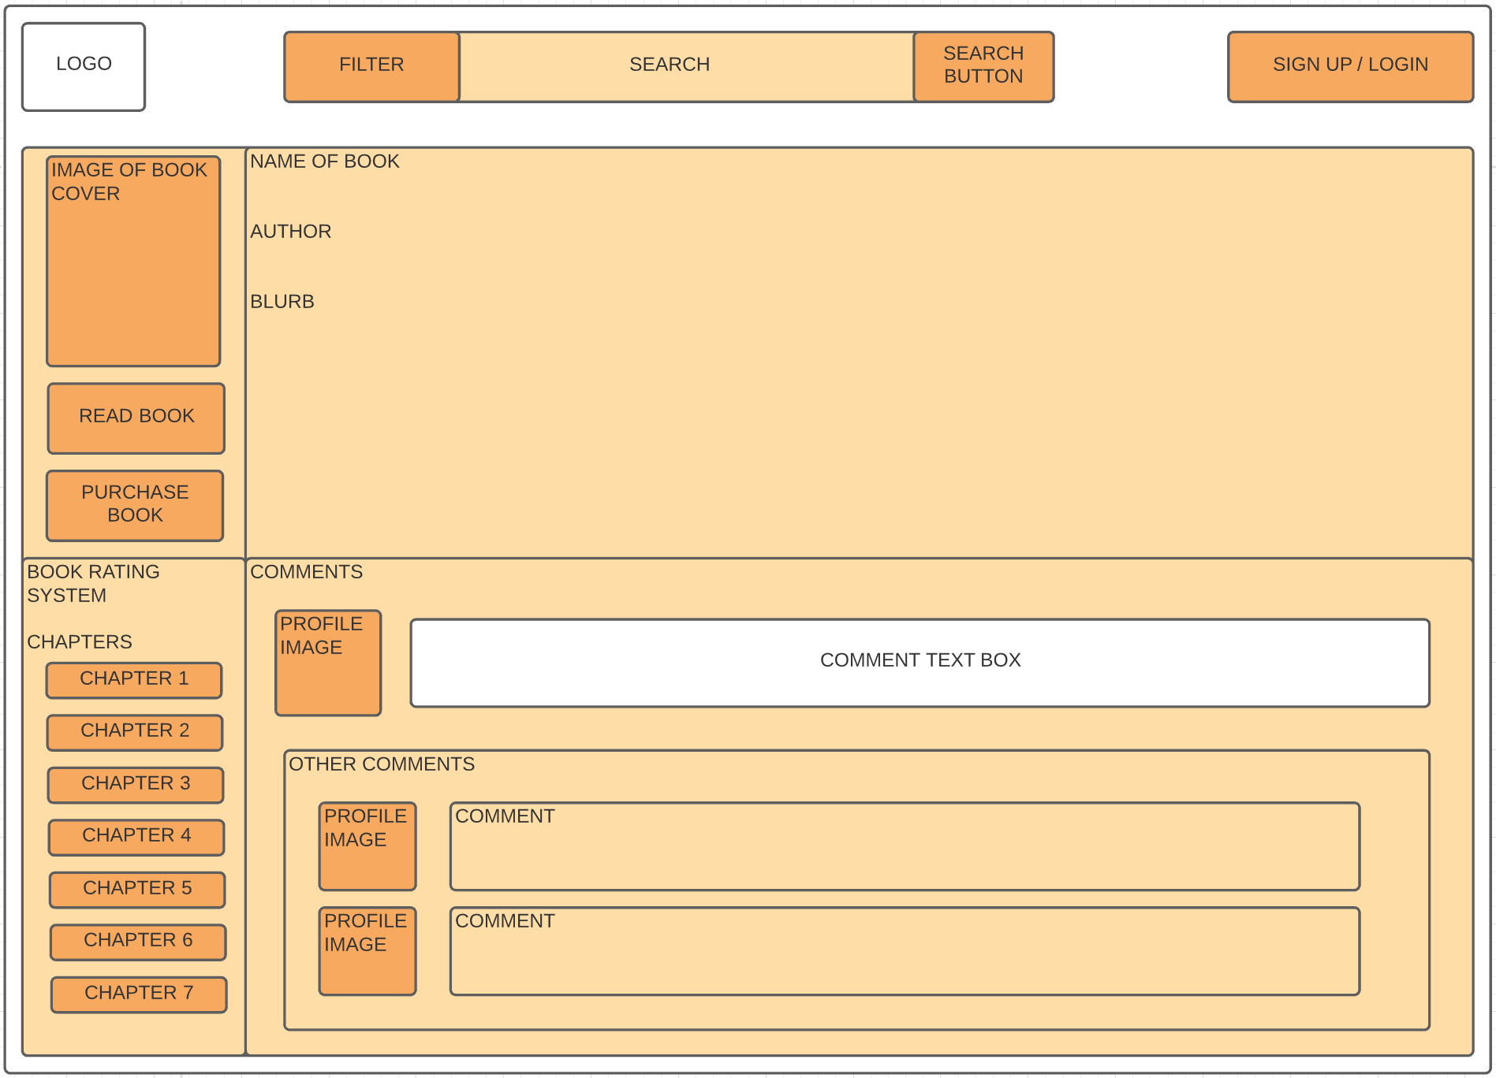

Button colour : Hex #f7a960 (Dark Orange)

Background banner colour : Hex #ffdda6 (Light Orange)

Text boxes for users: Hex #ffffff (White)

BOOK READING PAGE

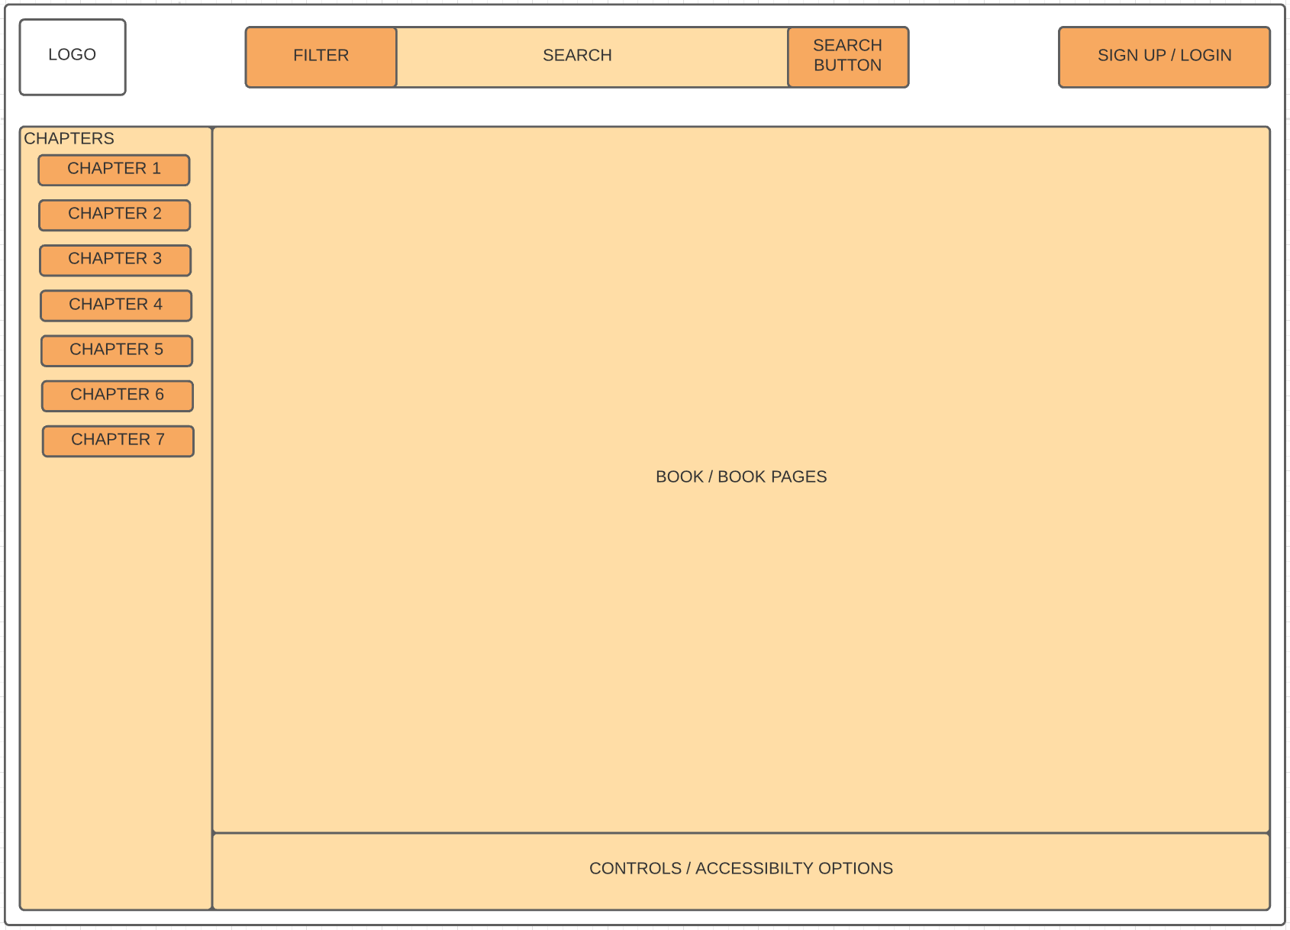

Button colour : Hex #f7a960 (Dark Orange)

Background banner colour : Hex #ffdda6 (Light Orange)

Text boxes for users: Hex #ffffff (White)

BOOK PURCHASE PAGE

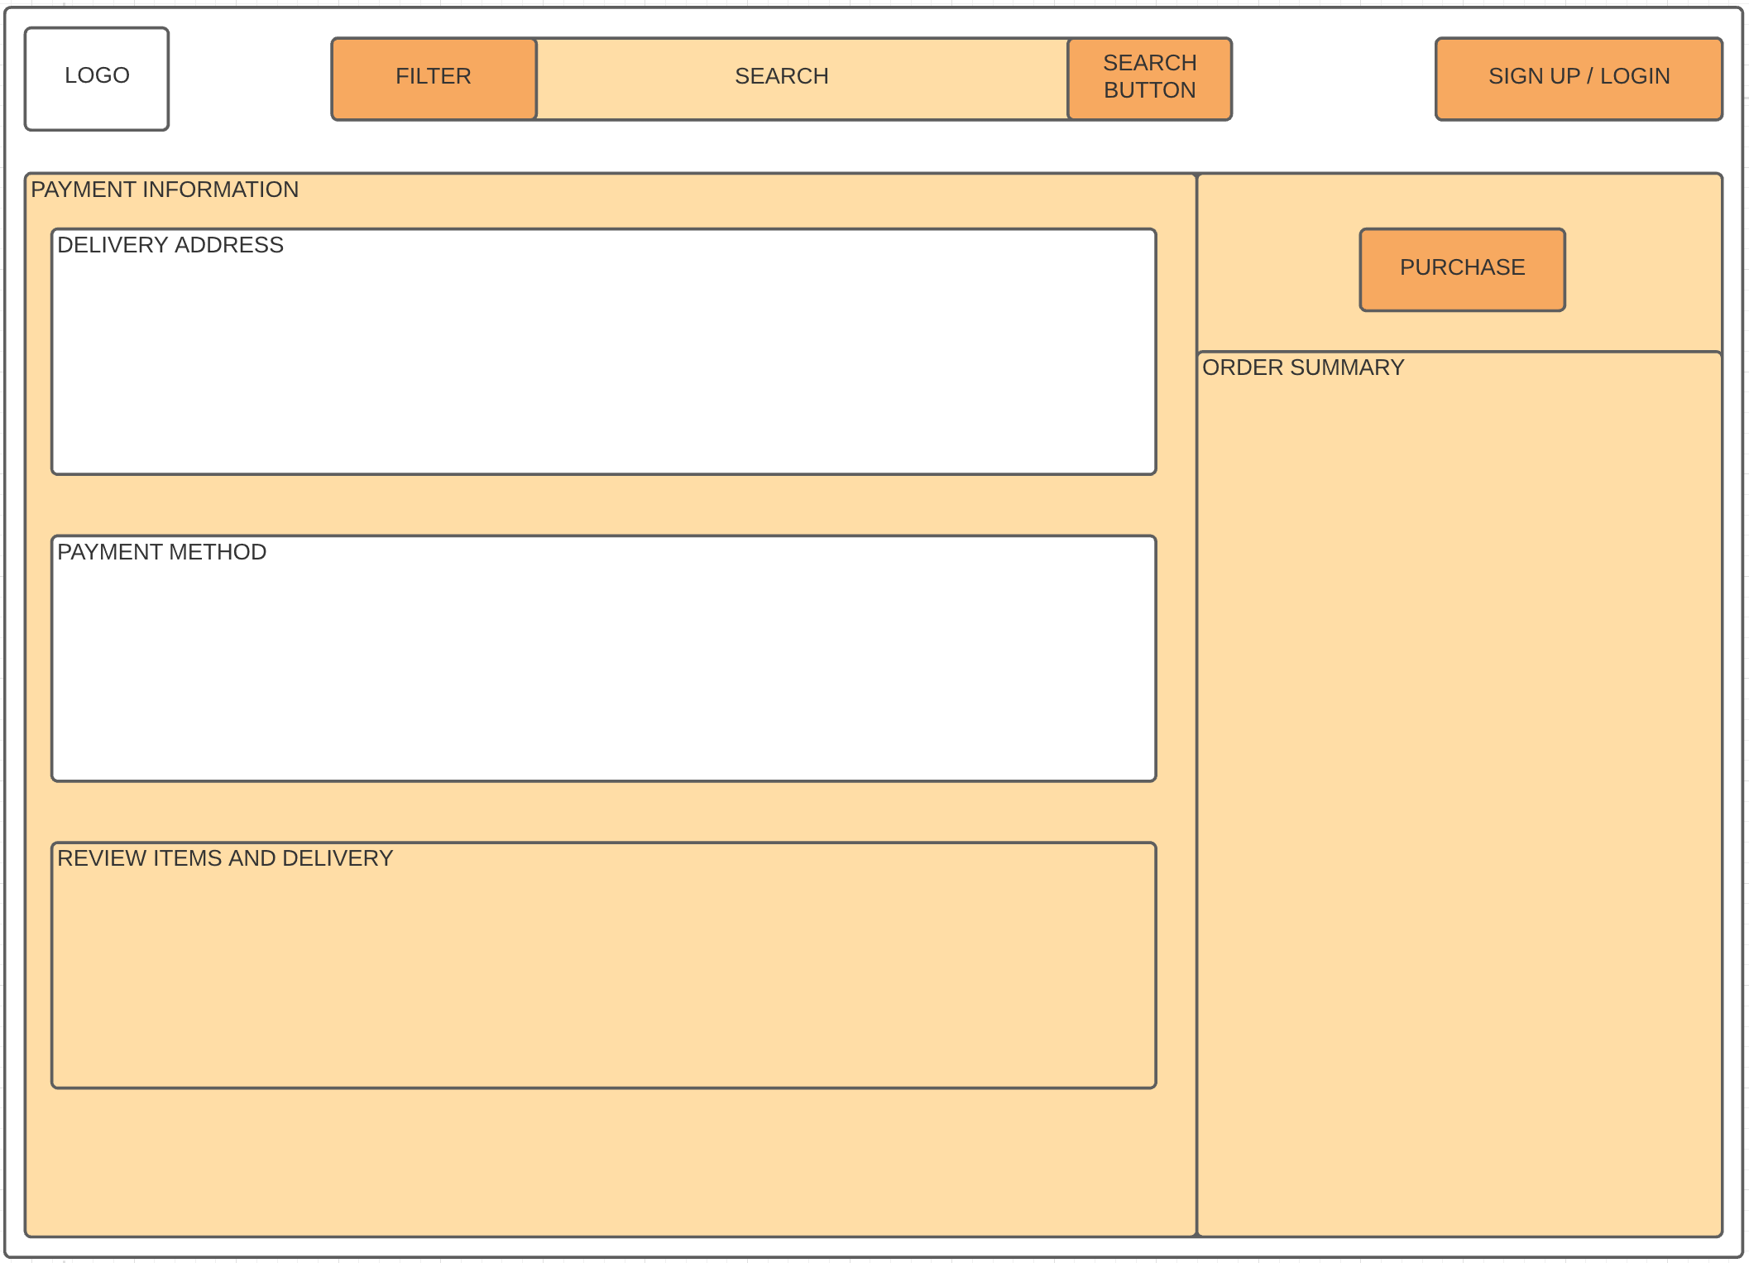

Button colour : Hex #f7a960 (Dark Orange)

Background banner colour : Hex #ffdda6 (Light Orange)

Text boxes for users: Hex #ffffff (White)